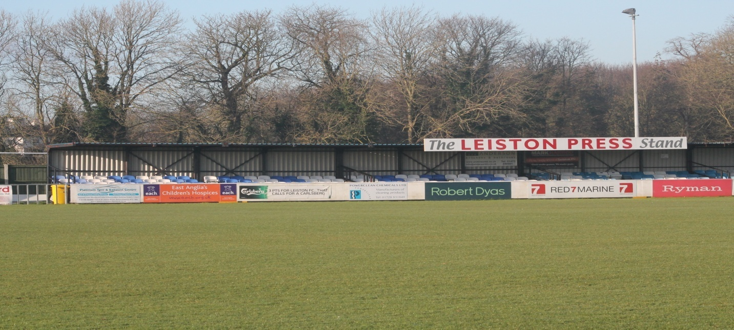

Home Fixtures in October

Sun | 15 | Haverhill Rovers | 10:00am | EJA
Sat | 21 | Folkestone Invicta | 3:00pm | BPL
Tue | 24 | Needham Market | 7:45 | TN1
Sat | 28 | Folkestone Invicta | 3:00pm | FAT
Sun | 29 | Histon | 10:00am | EJA

BPL – Bostik Premier, FAT FA Trophy
TN1 – Thurlow Nunn 1, TNYL – Thurlow Nunn Youth League
SYC – Suffolk FA Youth Cup, FAY – FA Youth Cup
EJA – Eastern Junior Alliance

Fixtures subject to change.

Please check our website www.leistonfc.co.uk
Follow us on
@leistonfc

